Installing your MARA app

1. **On your Mac Computer**
2. Download the .ipa file that was shared with you. 

Simply download the file and save it somewhere on your computer where you can easily locate it later.

1. Connect your device (iPhone, iPad) to your Mac that has iTunes installed.
2. Double click on the .ipa file that you downloaded earlier.
3. In iTunes, click on the device button in the top left corner.

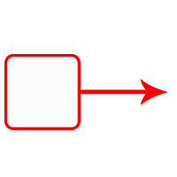Macintosh HD:Users:asugar:Desktop:Screen Shot 2015-04-07 at 8.23.46 AM.png

1. Click on Apps on the left side of the screen.

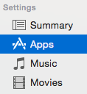

1. The Mara app should appear on the Apps list in the center of the screen. Under Apps, choose “Sort by Name” or “Sort by Kind” from the pop-up menu to find the Mara App if you don’t see it.

Click the Install button to the right of the Mara app. The button text changes to Will Install after you click Install.

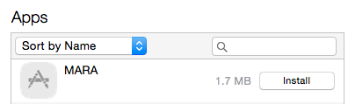

1. Click the Apply button in the lower-right corner to sync the device. Once the app is installed on your device, the button text to the right of Mara will change to Remove.

cid:517F23B3-935C-4CD0-B0A4-136AEFC5047E

**B.** **On Your Device (iPhone, iPad) please follow the instructions below:**

1. Go to Settings.



1. Scroll down and select the MARA app from your list of apps.
2. Please change the settings of the app under the section titled MARA SETTINGS:

* *Under the* ***Blog*** *section enter the following:*

URL: **social.rollins.edu/wpsites/mara**

Username:  **enter your foxid**

**(the same username you use for your Rollins email without the @rollins.edu)**

Password: **foxid password (the same password for your Rollins email)**

* *Under the* ***FTP SERVER*** *section enter the following:*

Note: Please notice the slashes in the beginning and the end. **There are no spaces.**

Host: **social.rollins.edu**

Directory: **/wpsites/wp-content/blogs.dir/152/files/uploads/**

Mask: **​/wpsites/mara/files/uploads/**  
Username: **[FTP USERNAME] eg. social.rollins.edu|yourfoxid**

**Example: social.rollins.edu|jsmith**

Password: **[FTP PASSWORD] eg. (foxid password)**

*Note: the* **|** *symbol in the FTP username (eg. social.rollins.edu|yourfoxid) can be found in additional symbols in the keypad (Press* **[123],***then* **[#+=]***,* **|***is the symbol third from the left on the second row.*